Documentazione progetto

Bacheca UniCollege

Building the web App:

The Main Class
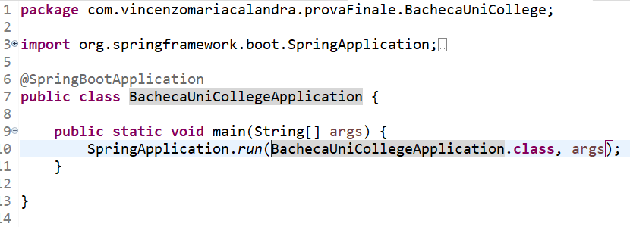
Notice how we're using "@SpringBootApplication" as our primary application configuration class.

Behind the scenes, that's equivalent to "@Configuration", "@EnableAutoConfiguration", and "@ComponentScan" together.

@SpringBootApplication is a convenience annotation that adds all of the following:
- @Configuration: Tags the class as a source of bean definitions for the application context.
- @EnableAutoConfiguration: Tells Spring Boot to start adding beans based on classpath settings, other beans, and various property settings. For example, if spring-webmvc is on the classpath, this annotation flags the application as a web application and activates key behaviors, such as setting up a DispatcherServlet.
- @ComponentScan: Tells Spring to look for other components, configurations, and services in the com/example package, letting it find the controllers.
The main() method uses Spring Boot’s SpringApplication.run() method to launch an application. Did you notice that there was not a single line of XML? There is no web.xml file, either. This web application is 100% pure Java and you did not have to deal with configuring any plumbing or infrastructure.

The Model View Controller Design
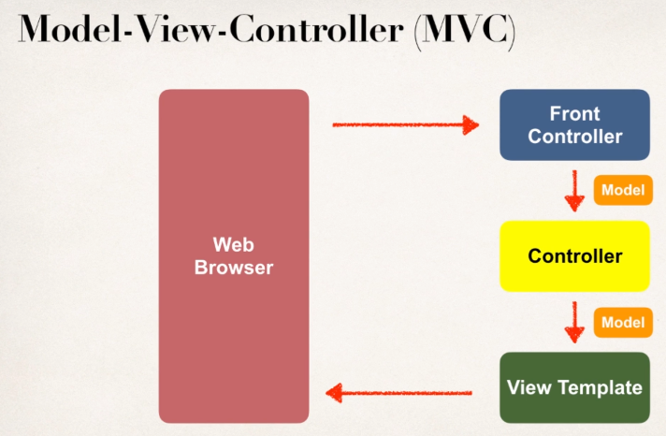 | 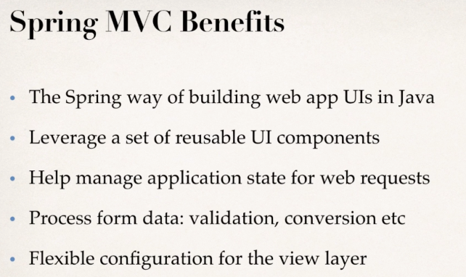
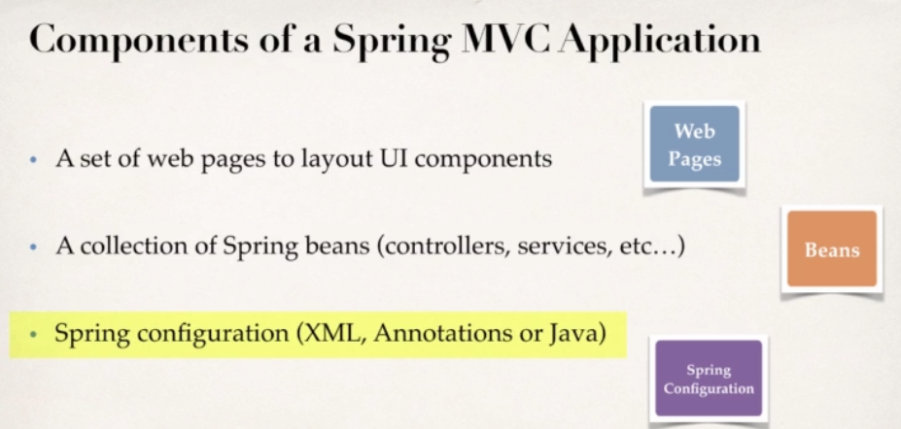 | 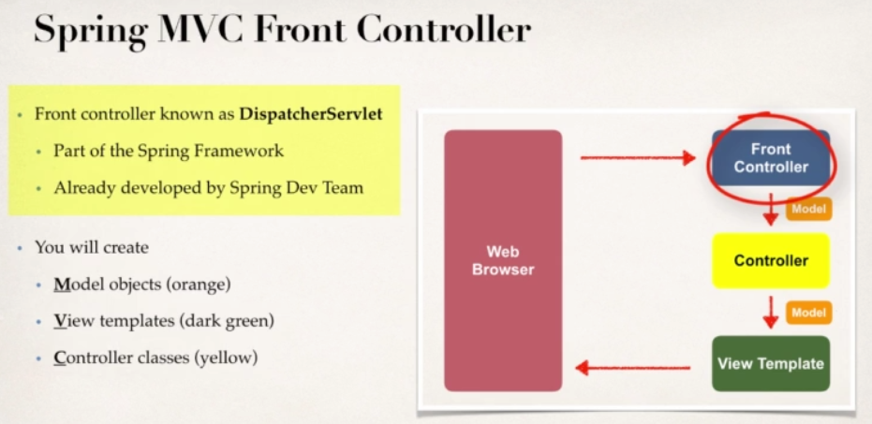
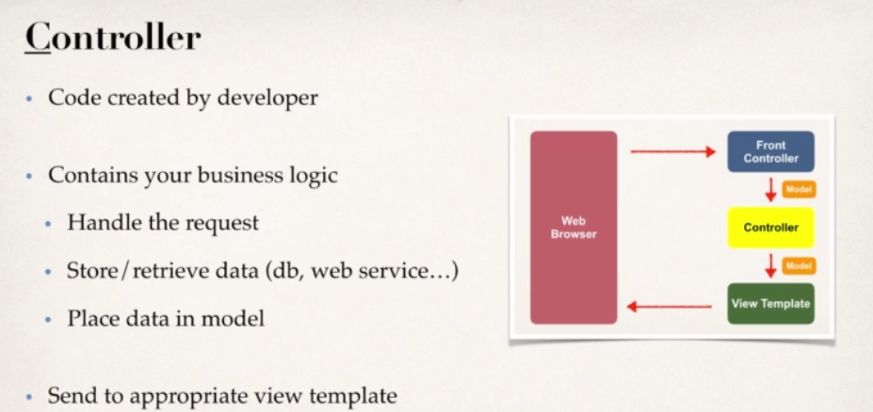 | 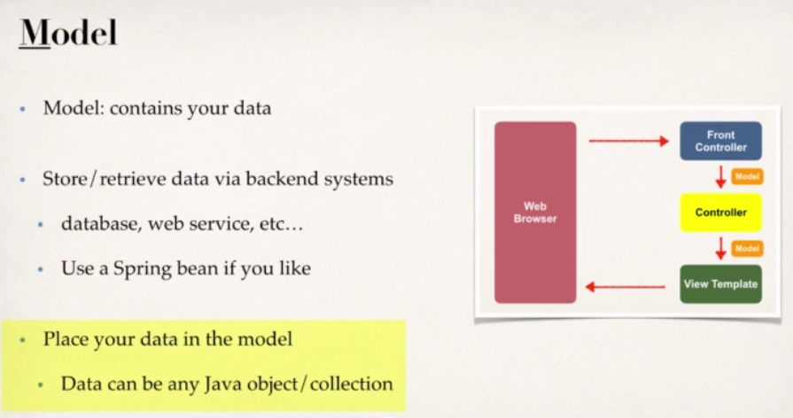
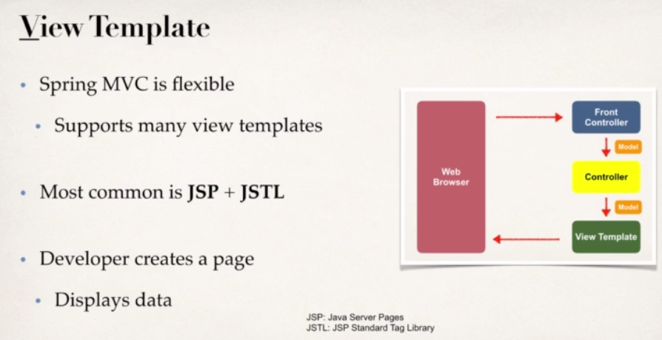

The Database connection

In this example, you store Customer objects, each annotated as a JPA entity. The following listing shows the Customer class (in src/main/java/com/example/accessingdatajpa/Customer.java):
package com.example.accessingdatajpa;

import javax.persistence.Entity;
import javax.persistence.GeneratedValue;
import javax.persistence.GenerationType;
import javax.persistence.Id;

@Entity
public class Customer {

@Id
@GeneratedValue(strategy=GenerationType.AUTO)
private Long id;
private String firstName;
private String lastName;

protected Customer() {}

public Customer(String firstName, String lastName) {
this.firstName = firstName;
this.lastName = lastName;
}

@Override
public String toString() {
return String.format(
"Customer[id=%d, firstName='%s', lastName='%s']",
id, firstName, lastName);
}

public Long getId() {
return id;
}

public String getFirstName() {
return firstName;
}

public String getLastName() {
return lastName;
}
}COPY
Here you have a Customer class with three attributes: id, firstName, and lastName. You also have two constructors. The default constructor exists only for the sake of JPA. You do not use it directly, so it is designated as protected. The other constructor is the one you use to create instances of Customer to be saved to the database.
The Customer class is annotated with @Entity, indicating that it is a JPA entity. (Because no @Table annotation exists, it is assumed that this entity is mapped to a table named Customer.)
The Customer object’s id property is annotated with @Id so that JPA recognizes it as the object’s ID. The id property is also annotated with @GeneratedValue to indicate that the ID should be generated automatically.
The other two properties, firstName and lastName, are left unannotated. It is assumed that they are mapped to columns that share the same names as the properties themselves.
The convenient toString() method print outs the customer’s properties.

Utility Packages

Contains Enum Class of Activity_credits and Activity_type. To map an Enum of type Double in JPA we need a converter.

JPA 2.1 release introduced a new standardized API that can be used to convert an entity attribute to a database value and vice versa. All we need to do is to create a new class that implements javax.persistence.AttributeConverter and annotate it with @Converter.

We've set the @Converter‘s value of autoApply to true so that JPA will automatically apply the conversion logic to all mapped attributes of a Category type. Otherwise, we'd have to put the @Converter annotation directly on the entity's field.

As we can see, we can simply set our own rules of converting enums to a corresponding database value if we use the AttributeConverter interface. Moreover, we can safely add new enum values or change the existing ones without breaking the already persisted data.
The overall solution is simple to implement and addresses all the drawbacks of the options presented in the earlier sections.

Application Properties File
The values create, create-drop, validate, and update basically influence how the schema tool management will manipulate the database schema at startup.
For example, the update operation will query the JDBC driver's API to get the database metadata and then Hibernate compares the object model it creates based on reading your annotated classes or HBM XML mappings and will attempt to adjust the schema on-the-fly.
The update operation for example will attempt to add new columns, constraints, etc but will never remove a column or constraint that may have existed previously but no longer does as part of the object model from a prior run.
Typically in test case scenarios, you'll likely use create-drop so that you create your schema, your test case adds some mock data, you run your tests, and then during the test case cleanup, the schema objects are dropped, leaving an empty database.
In development, it's often common to see developers use update to automatically modify the schema to add new additions upon restart. But again understand, this does not remove a column or constraint that may exist from previous executions that is no longer necessary.
In production, it's often highly recommended you use none or simply don't specify this property. That is because it's common practice for DBAs to review migration scripts for database changes, particularly if your database is shared across multiple services and applications.

